**SFTP Connector**

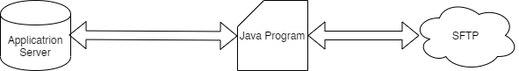

Input Parameters of Java Program:

* Host
* User Id
* Password
* Application folder absolute path (E:\SAP\PSA\)
* Ftp folder Absolute path (inbound/)
* File Transfer mode
  + CFA – For copying files from Application Server to SFTP
  + CFF – For coping files from SFTP to Application Server
* Operational Parameters
  + FA – Read all the files from Application Server and copy it to SFTP folder irrespective of filename parameters and vice versa
  + FP – Read all the files from Application Server and copy it to SFTP folder based on matching the file name of the filename convention parameters and vice versa
  + FS – Fetch a single file which is provided in the filename convention parameters.
* File Name Convention
  + This can be null
  + This may have the initial string of a file naming convention
  + This may have the actual file name

Operational Procedures:

* SAP frontend call a shell script stored in to the SAP application server.
* Shell Script runs the java program using 8 parameters
* Based on the parameters mentioned about java program read a specific folder from application server and copy it to ftp server one by one. If the copy is successful then it deletes from the origin folder and vice versa process.